**Add/View/Edit Products**

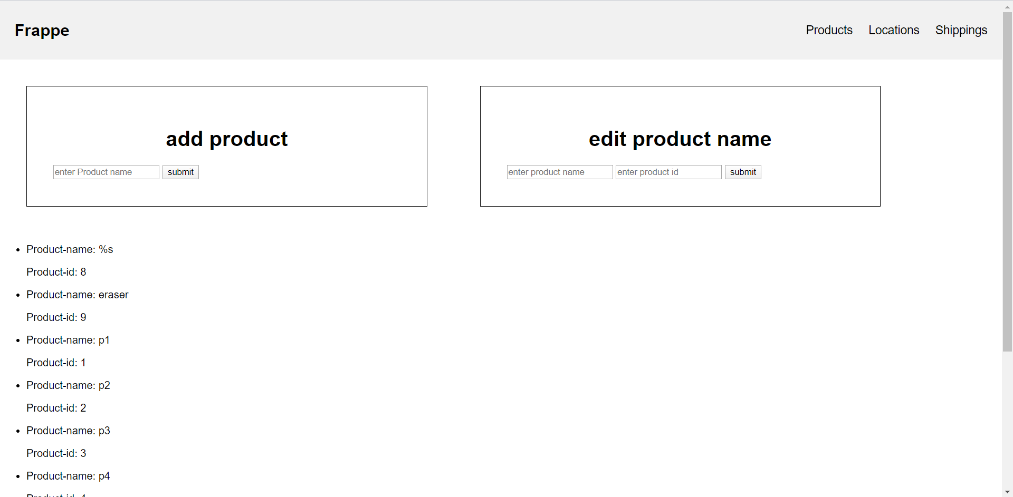

**Add/View/Edit Locations**

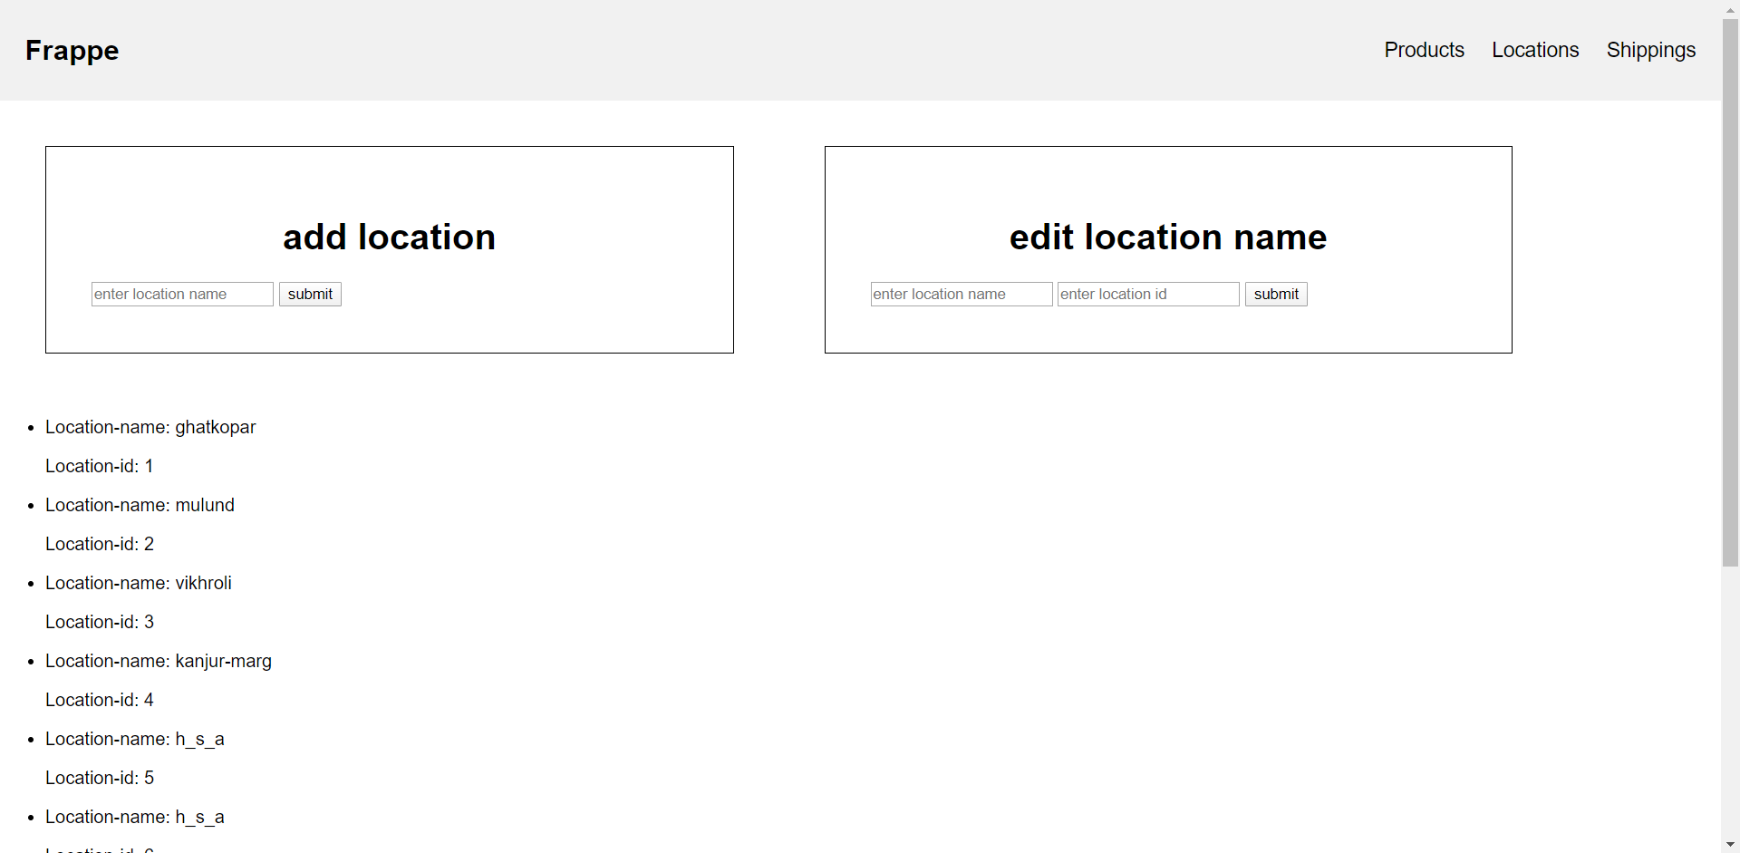

**Add/View/Edit Movements of Orders**

Import and export options to warehouse have also been provided

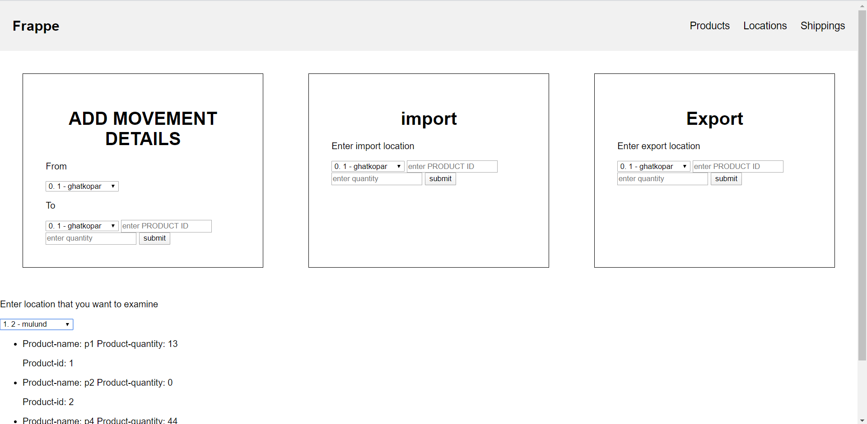

**Importing item 7 to ghatkopar branch with import form**

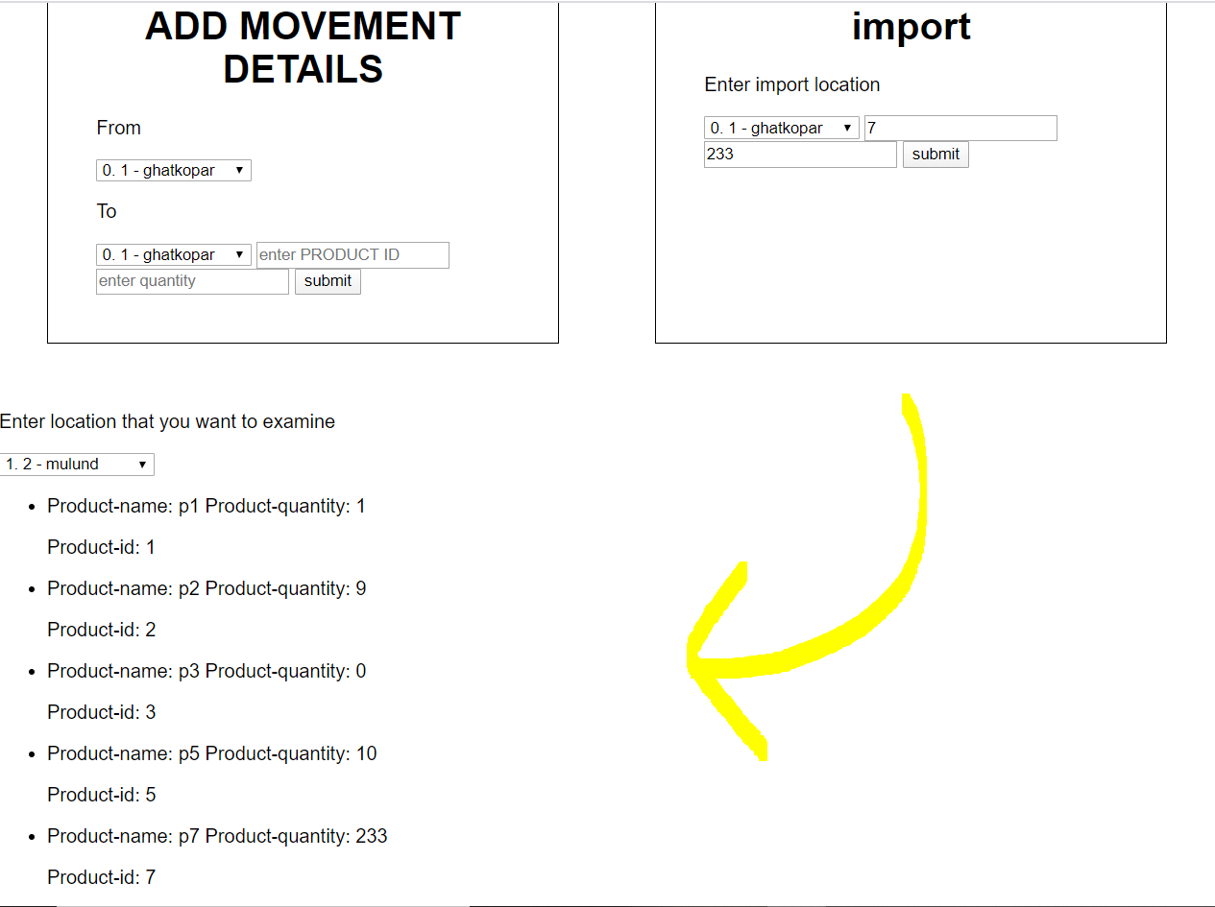

**Putting item 7 from ghatkopar to mulund**

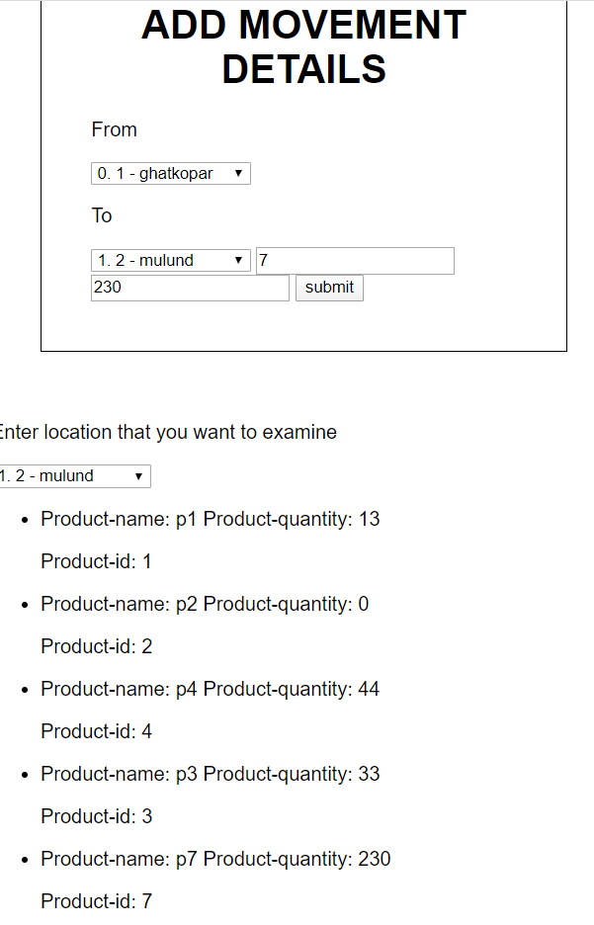

**Exporting 200 units of item 7 from mulund Therfore 30 remain**

